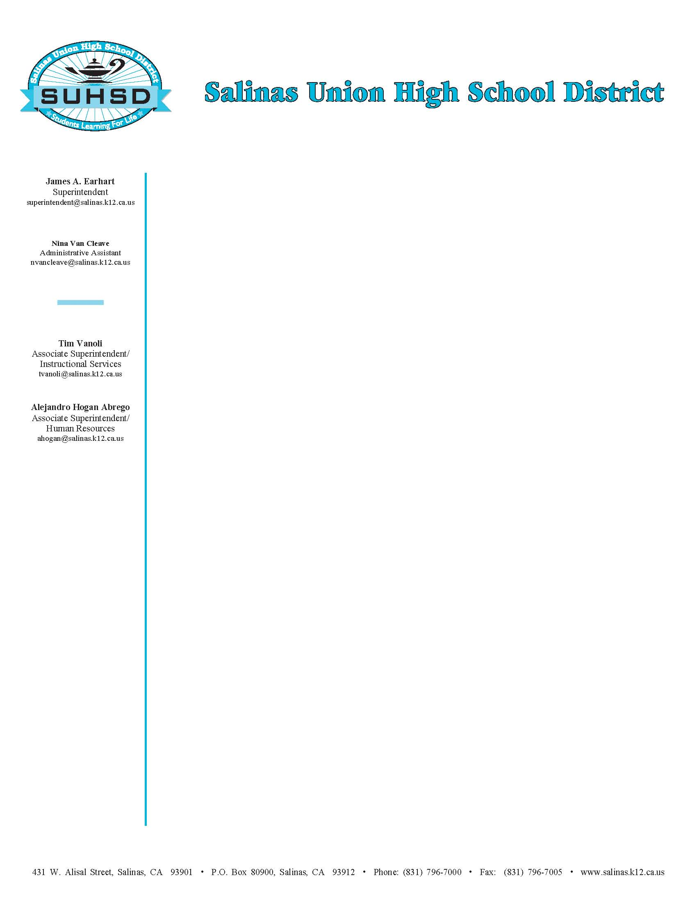
Alberto Verduzco
Interim Assistant Superintendent
Human Resources
alberto.verduzco@salinasuhsd.org
October 6, 2018

To: All Contractors

RE: SUHSD APPEALS PROCESS: AB 1565 Contractor Qualification Lists

A contractor who has submitted a completed application form and who receives a rating of “not qualified” from the District may appeal that determination. There is no appeal from a finding that a contractor is not prequalified because of a late application or a failure to submit required information, but re-application during one of the designated “prequalification periods” is permitted. The date for submission and the date fixed for receipt of bids for a specific project will not be delayed or postponed to allow for completion of an appeal process. Unless a Contractor files a timely appeal, the Contractor waives any and all rights to challenge the qualification decision of the District, whether by administrative process, judicial process or any other legal process or proceeding.

- Appeal must be filed in writing with the Director of General Services within two business days after receipt of the prequalification determination.

- The Director of General Services will convene a meeting with the requestor to attempt to resolve the problem.

- In the event the appeal is not resolved, the appeal will be referred to the Superintendent or their designee, normally the Manager of Business Services/CBO.

- Should the appeal not be resolved at this level, it shall be referred to the Board along with all documentation regarding the appeal and the responses at each level.

- The Board will not act upon an appeal until each of the proceeding steps has been exhausted.

Ana V. Aguillon
Manager of
Business Services/CBO
ana.aguillon@salinasuhsd.org
Dr. Blanca Baltazar-Sabbah
Associate Superintendent
Instructional Services
blanca.baltazar@salinasuhsd.org

Dan Burns
Superintendent
dan.burns@salinasuhsd.org
431 West Alisal Street, Salinas, CA 93901 ∙ Phone: (831) 796-7000 ∙ Fax: (831) 796-7005 ∙ www.salinasuhsd.org

